**Creating Virtual Machines on Hyper-V Host**

* Login into the Hyper V host and ensure Vagrant is working  
  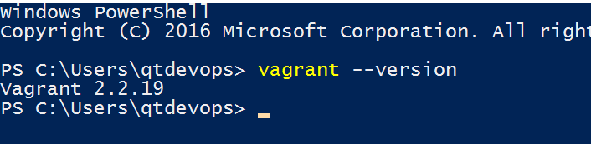
* Lets create a centos 8 vm on Hyper V Host [Refer Here](https://app.vagrantup.com/centos/boxes/7)
* Create a folder and execute vagrant init centos/7
* Now execute vagrant up --provider hyperv  
  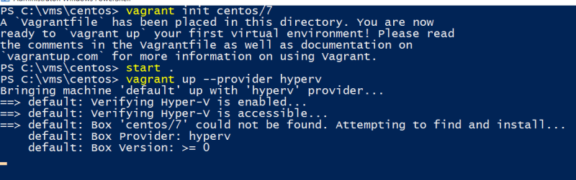
* Now Manually navigate to hyper v manager and set MAC spoofing and Power on the virtual machine
* login into the virtual machine with username vagrant and password vagrant
* Now execute sudo yum update
* Now lets install apache server on this machine

sudo yum install httpd -y

sudo systemctl enable httpd

sudo systemctl start httpd

sudo systemctl status httpd

* Now access the Apache server from hyper-v host using the Guest VM (Centos VM) ip address  
  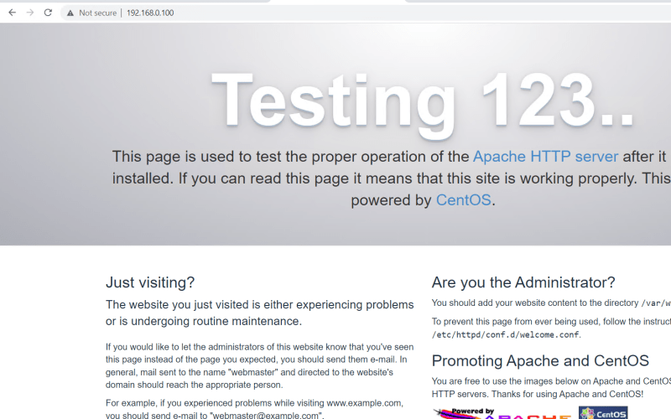
* Now lets create an ubuntu 18 vm with tomcat 9.
* Lets use the following box [Refer Here](https://app.vagrantup.com/generic/boxes/ubuntu1804)
* Create a new folder and execute vagrant init generic/ubuntu1804 and then vagrant up --provider hyperv  
  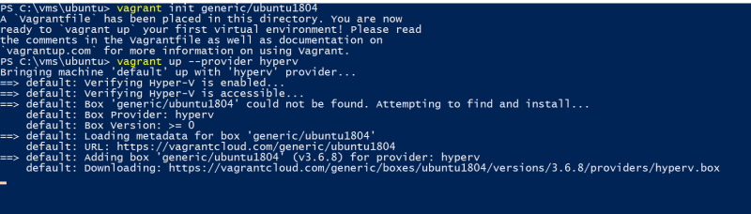
* Now Manually navigate to hyper v manager and set MAC spoofing and Power on the virtual machine
* login into the virtual machine with username vagrant and password vagrant
* Now execute sudo apt update
* Now lets install tomcat9 [Refer Here](https://linuxhint.com/install_apache_tomcat_server_ubuntu/)